World premiere: PH Cell Twin
With the ergonomic Twin solution, DMG MORI enables automation for two machining centers.

PH Cell Twin: modular and compact pallet handling for two machines

In the production of small batches, DMG MORI's PH Cell 300 and PH Cell 2000 have proven themselves with their high degree of flexibility and ease of operation. With the world premiere of the PH Cell Twin, the machine tool manufacturer is now expanding the range of its compact and modular pallet handling systems. The consistent development of the successful concept is designed to flexibly automate two machining centers. Depending on the design of the storage unit, it offers space for up to 30 pallets. The PH Cell Twin is compatible with various models of the DMU monoBLOCK, DMU H monoBLOCK and DMU eVo series as well as with the DMU 50 and the CMX U series. Both the pallet handling itself and the second machine are retrofittable.

Automation solutions reduce personnel expenses during non-productive times and extend production capacity to unmanned night and weekend shifts. Against the background of increasing component variance and smaller batch sizes, flexible automation concepts are particularly in demand. DMG MORI meets precisely this requirement with the pallet handling systems of the PH Cell series, which now also includes a solution for two machines – the PH Cell Twin.

Modular design for individual storage configuration
The PH Cell Twin can be loaded with up to 30 pallets of 320 x 320 mm. Larger pallets of 400 x 400 mm or 500 x 500 mm can be loaded with 24 and 18 pallets respectively. Different sizes can also be combined in the system. The pallets are arranged in two rows, making the automation very compact. The maximum workpiece size is ø 500 x 500 mm with a workpiece weight of 300 kg including the pallet. The pallets can be set up ergonomically and in parallel with production time via the separate, optionally rotatable set-up station.

Retrofittable and expandable
Thanks to its defined interface and modular design, the PH Cell Twin can be put into operation quickly and easily. Like its sister products, the new version can also be easily retrofitted to machining centers with an existing automation interface. The same applies to the connection of the second machine, which means that this investment can be postponed to a later date. All common smaller 5-axis machining centers are compatible with the PH Cell Twin: the DMU 65 / 75 monoBLOCK, the DMU 65 H monoBLOCK, the DMU 50 3rd Generation, the DMU 40 / 60 eVo and the CMX 50 / 70 U. Of course, the PH Cell Twin can also load two different machine models with pallets.

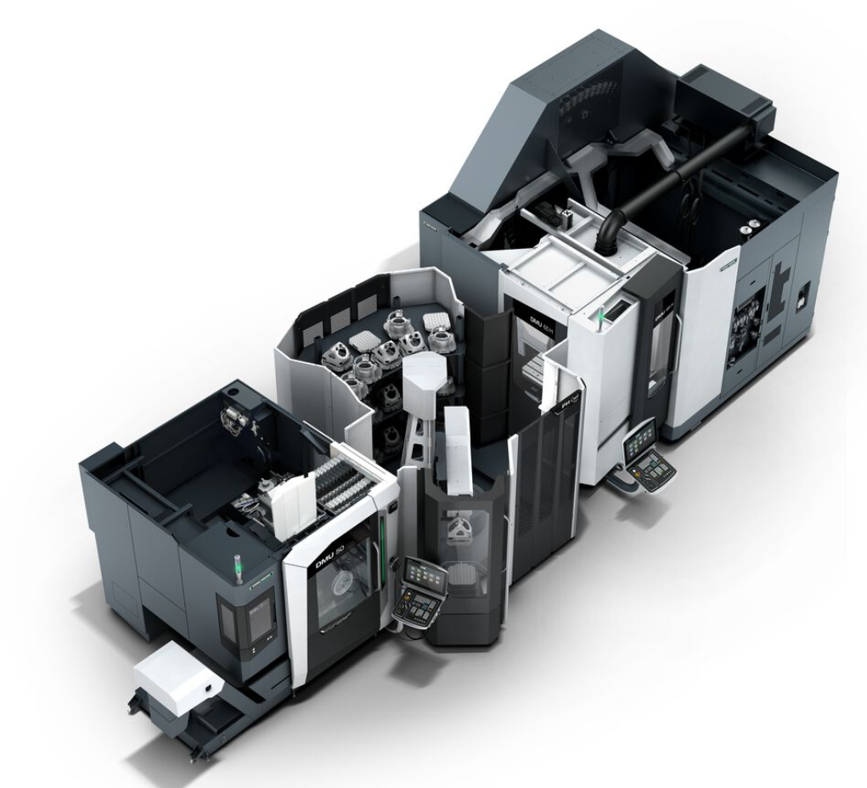

PH Cell Twin with DMU 50 and DMU 65 H monoBLOCK
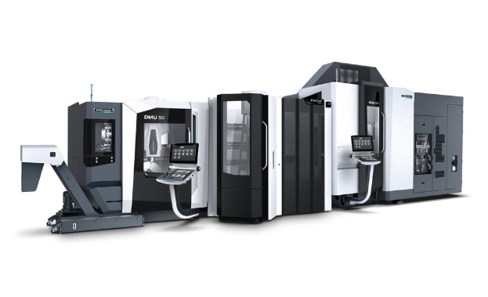
Retrofittable: Connection to existing machine with already integrated automation
interface possible. Extendable: Subsequent connection of a second machine possible.

